**EXPERIMENT - 8**

**AIM:**

To study Analog Multiplexing and Demultiplexing Techniques- Frequency Division Multiplexing and Demultiplexing

**THEORY:**

When several communications channels are between the two same point‟s significant economics may be realized by sending all the messages on one transmission facility a process called multiplexing.

Applications of multiplexing range from the vital, if prosaic, telephone networks to the glamour of FM stereo and space probe telemetry system. There are two basic multiplexing techniques

1. Frequency Division Multiplexing (FDM)

2. Time Division Multiplexing (TDM)

The principle of the frequency division multiplexing is that several input messages individually modulate the sub carrier‟s fc1, fc2, etc.after passing through LPFs to limit the message bandwidth. We show the sub carrier modulation as SSB, and it often is; but any of the CW modulation techniques could be employed or a Mixture of them. The modulated signals are then summoned to produce the base band signal with the spectrumXb9f), the designation “base band” is used here to indicate that the final carrier modulation has not yet taken place.

The major practical problem of FDM is cross talks, the unwanted coupling of one message into another. Intelligible cross talk arises Primarily because of non linearity‟s in the system, which cause 1 message signal to appear as modulation on sub carrier? Consequently, standard practice calls for negative Feedback to minimize amplifier non linearity in FDM systems.

**CIRCUIT DIAGRAM:**

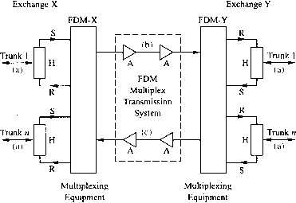

**MATLAB CODE:**

Fs = 100; % sampling freq

t = [0:2*Fs+1]'/Fs;

x1 = sin(2*pi*2*t); % signal 1 signal

figure;

subplot(4,1,1);

plot(x1);

title('signal 1');

xlabel('time');

ylabel('amplitude');

x2 = sin(2*pi*10*t); % signal 2 signal

subplot(4,1,2);

plot(x2);

title('signal 2');

xlabel('time');

ylabel('amplitude');

z1 = fft(x1); %Fourier transform of signal 1

z1=abs(z1); %Returns absolute value of fourier transform of signal 1

subplot(4,1,3);

plot(z1);

title('Spectrum of signal 1');

xlabel('freqency');

ylabel('magnitude');

z2 = fft(x2); %Fourier transform of signal 2

z2=abs(z2); %Returns absolute value of fourier transform of signal 2

subplot(4,1,4);

plot(z2);

title('Spectrum of signal 2');

xlabel('freqency')

ylabel('magnitude');

% freqency multiplexing

z=z1+z2;

figure;

plot(z);

title('frequency multiplexed signals');

figure;

% freqency demultiplexing

f1=[ones(10,1); %Returns a 10 by 1 array of ones

zeros(182,1);

ones(10,1)]; %applying filter for signal 1

dz1=z.*f1;

d1 = ifft(dz1); %Inverse transform of each column of ones matrix

subplot(2,1,1)

plot(t*100,d1);

title('Demultiplexed signal 1');

xlabel('time');

ylabel('amplitude');

f2=[zeros(10,1); %Returns a 10 by 1 array of ones

ones(182,1);

zeros(10,1)];% applying filter for signal 2

dz2=z.*f2;

d2 = ifft(dz2); %Inverse transform of each column of ones matrix

subplot(2,1,2)

plot(t*100,d2);

title('Demultiplexed signal 2');

xlabel('time');

ylabel('amplitude');

**WAVEFORM OBTAINED:**

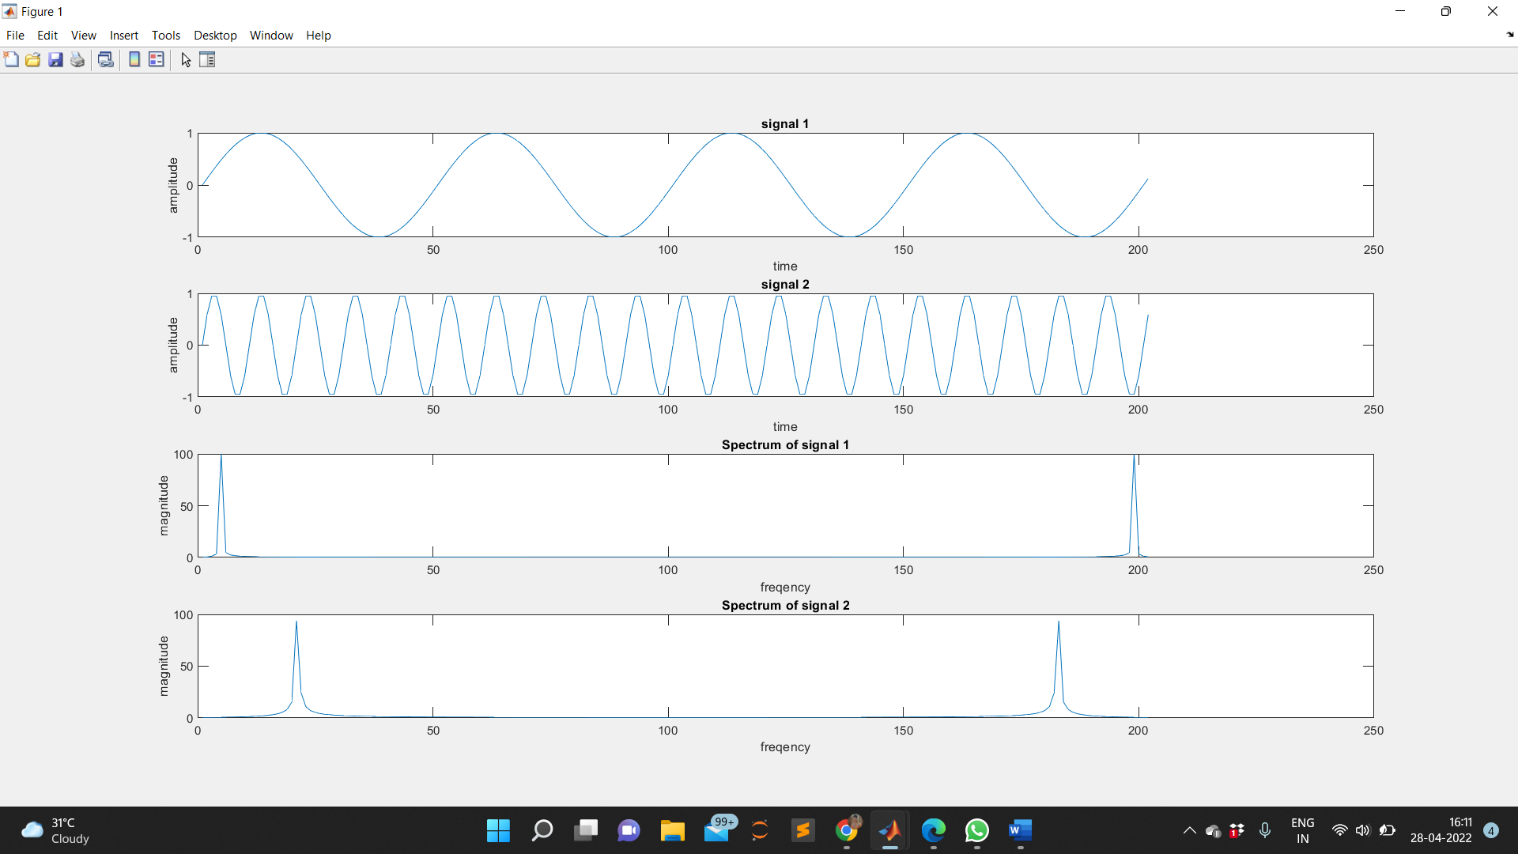

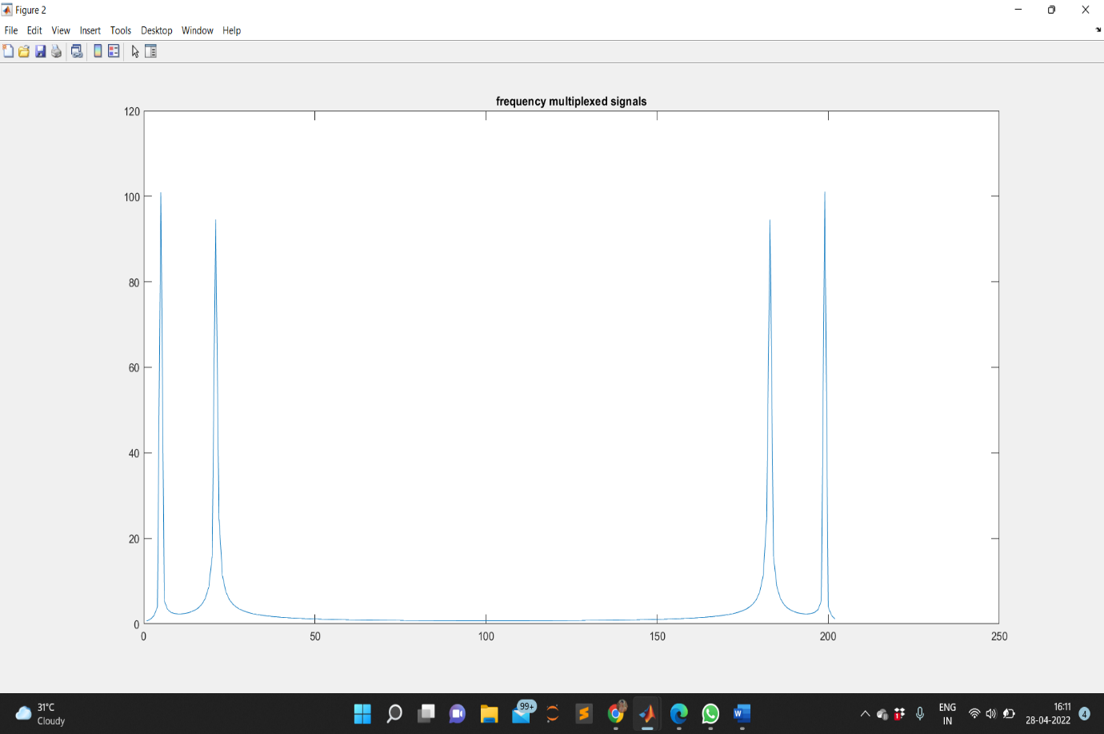

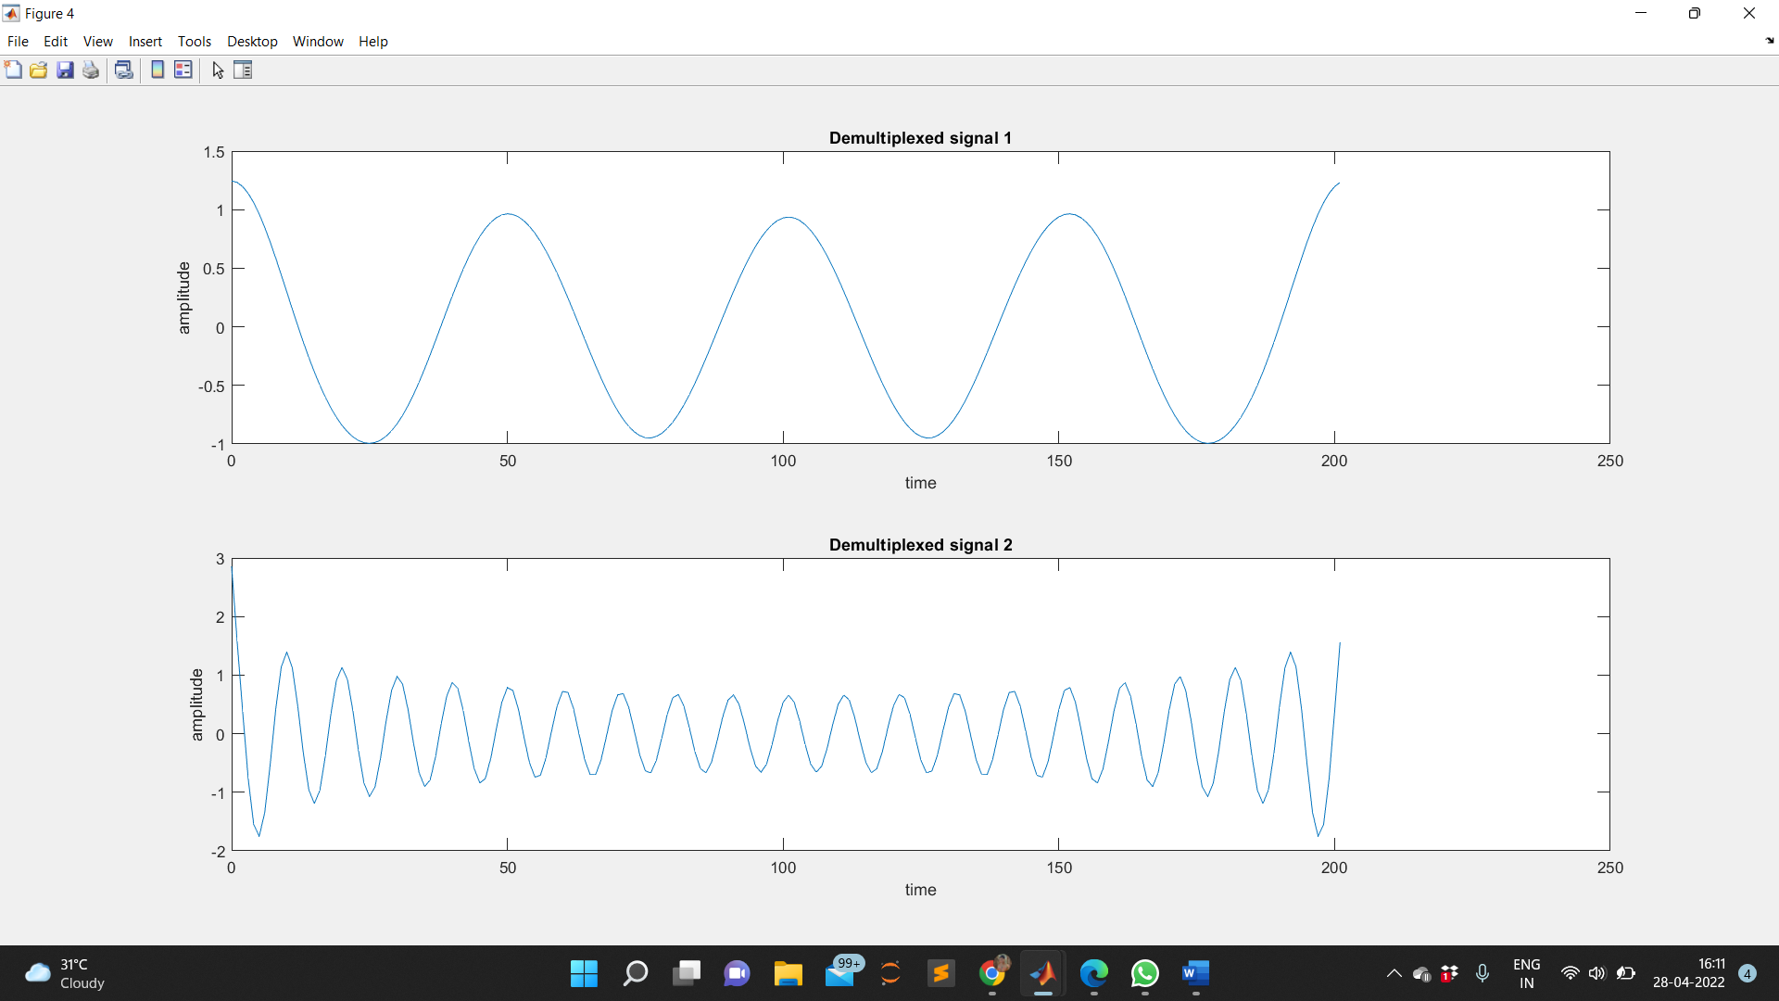

**RESULT:**

The frequency division multiplexing and demultiplexing of analog multiplexing is studied, verified and the output waveforms are plotted.

**APPLICATIONS:**

1. FDM is used for FM & AM radio broadcasting. AM broadcasting uses a bandwidth of 550-1650 KHz, where as FM broadcasting used a bandwidth of 88-108 MHz

2. FDM is used in Television broadcasting.

3. First generation Cellular telephone also uses FDM.

4. Used in Stereo FM transmissions.

5. Twentieth century telephone companies used FDM for long-distance connections to multiplex thousands of voice signals through co-axial cable systems.

6. Telemetry a. Used to send feedback from multiple sensors over a single channel

7. Telephone Systems a. Had been used for decades to send multiple telephone conversations over a minimum number of cables b. The multiplexing process is used at multiple levels to send 10,800 phone calls over a single channel

8. Cable TV a. Multiple TV signals are multiplexed on a common coaxial cable